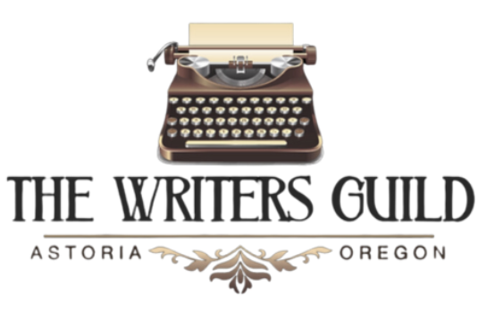
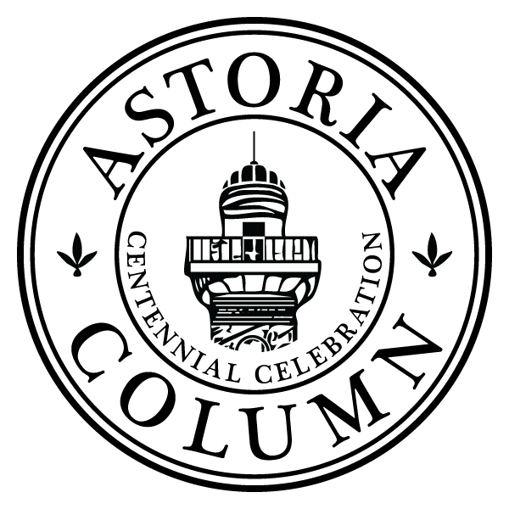
FOR IMMEDIATE RELEASE
Contact:
The Writers Guild
info@thewritersguild.org
astoria-column-writing-contest

Writing Contest Announced to Honor
100th Anniversary of the Astoria Column
ASTORIA, OR (April 2, 2026)— In celebration of the 100th anniversary of the Astoria Column, Friends of Astoria Column, in partnership with The Writers Guild, is proud to announce a statewide writing contest inviting Oregon writers to reflect on the rich history, meaning, and legacy of this iconic landmark.
Dedicated in 1926, the Astoria Column stands high above the meeting of river and sea as a monument to the layered history of the region—honoring Indigenous presence, exploration, migration, industry, and resilience. For a century, it has risen above forest and fog, its spiral frieze telling the story of the Pacific Northwest in enduring form.
To commemorate this centennial milestone, writers are invited to submit original, unpublished work that engages with the Astoria Column—its history, symbolism, physical presence, or the perspective it offers. Submissions may explore themes such as arrival, migration, inheritance, legacy, resilience, storytelling, landscape, and the spiral nature of history itself. Work may be contemporary or historical, intimate or expansive.
“We’re thrilled to celebrate the 100th anniversary of the Astoria Column by inviting writers to respond to its legacy through their own voices. The Column has long stood as a symbol of history, storytelling, and perspective and this contest feels like a natural extension, bringing our community’s current stories into conversation with the past.”
— Marianne Monson, Guild Executive Director
Contest Categories and Guidelines:
- Poetry: Up to three poems per entrant, with a maximum of 50 lines per poem
- Memoir / Personal Essay: Up to 2,000 words
The contest is open to all Oregon and Washington residents of all ages and backgrounds, with categories for Adults, Teens (13–17), and Children (7–13). Each writer may submit one entry per genre.
Submissions should include the writer’s name, contact information, and a brief third-person biography (50 words or fewer), and must be emailed to info@thewritersguild.org by midnight, May 31, 2026.
Distinguished Judges:
- Ellen Waterston, Oregon Poet Laureate
- Cheryl Strayed, author of Wild
- Marianne Monson, Executive Director, The Writers Guild
Winners in each category will receive a $100 gift card to Lucy’s Bookstore along with an Astoria Column Centennial commemorative gift package.
Selected works will be featured at the Astoria Column Centennial Community Celebration on July 18, 2026, and showcased on the official Centennial website.
This contest offers a unique opportunity for writers to contribute to the living story of the Lower Columbia region and to honor a century-old landmark that continues to inspire reflection and creativity.
For more information, please contact The Writers Guild at info@thewritersguild.org.
###
About the Astoria Column
The Astoria Column is a 125-foot-tall monument located in Astoria, Oregon. Dedicated in 1926, it features a hand-applied sgraffito mural, the only one of its kind in the world, illustrating significant events in Oregon and Pacific Northwest history, from Native American heritage to the Lewis and Clark Expedition The Column is listed on the National Register of Historic Places and remains one of Oregon’s most beloved historic landmarks.
About The Writers Guild
Our mission is to support the writing community of Astoria and the Lower Columbia, while fostering the unique literary arts in our region. In partnership with local authors, Marianne Monson, founded the Guild to connect writers and foster the literary arts in 2018.
A 501(c)(3) status organization, the Guild’s projects include creative writing clubs, hosted readings, writing workshops, literary balls, a writer-in-residency program, and welcoming authors such as Kim Stafford, Karl Marlantes, and Jericho Brown for an annual creative writing festival. We celebrate the beauty and importance of language and believe a literate community is a thriving community.

